


Microsoft Azure – FTP Setup Guide



Create an Account with Microsoft Azure
https://portal.azure.com
Create a Virtual Machine
Example: Create virtual machine
- Click Create a resource in the upper left-hand corner of the Azure portal.
- Select Compute, and then select Windows Server 2016 Datacenter.
- Enter the virtual machine information. The user name and password entered here is used to log in to the virtual machine. The password must be at least 12 characters long and meet the defined complexity requirements. Choose a Location such as East US 2 that supports availability zones. When complete, click OK.
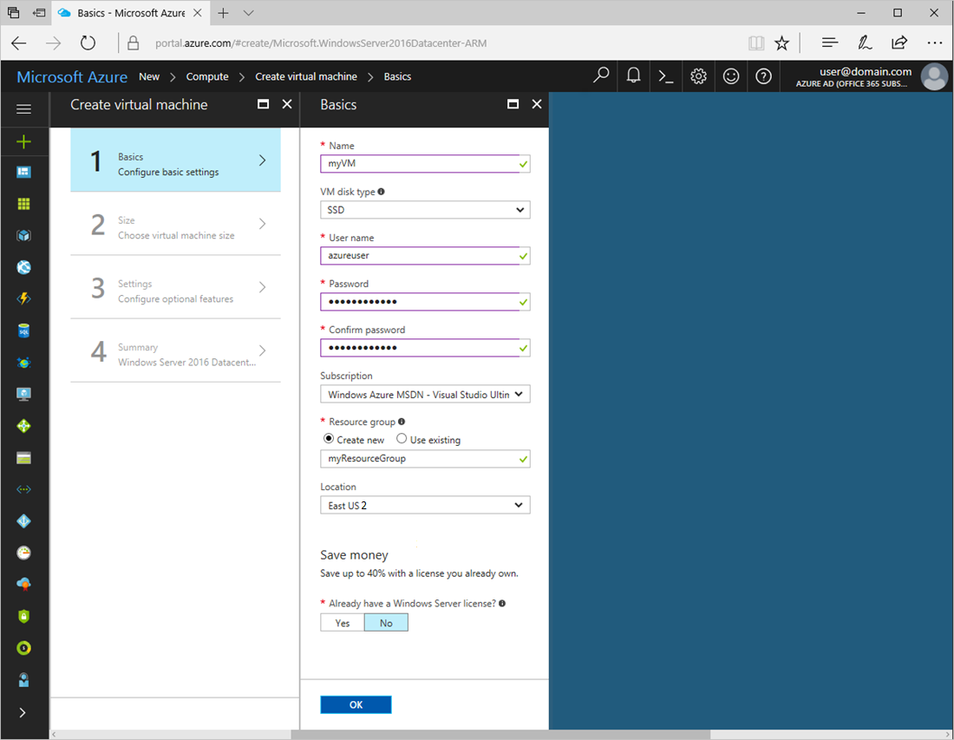

4. Choose a size for the VM. Select a recommended size, or filter based on features. Confirm the size is available in the zone you want to use.
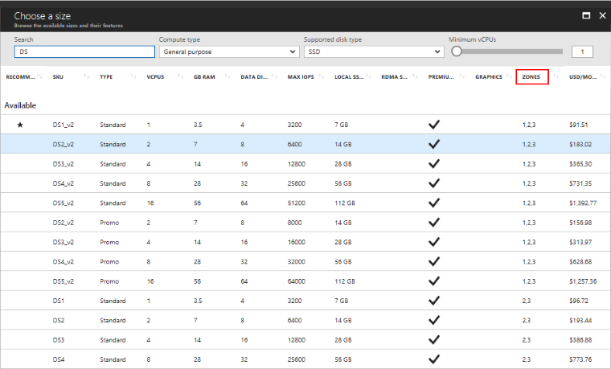

5. Under Settings > High availability (Not required), select one of the numbered zones from the Availability zone dropdown, keep the remaining defaults, and click OK.
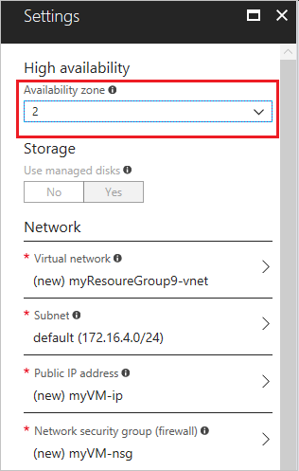
6. On the summary page, click Create to start the virtual machine deployment.
7. The VM will be pinned to the Azure portal dashboard. Once the deployment has completed, the VM summary automatically opens.
Confirm zone for managed disk and IP address
When the VM is deployed in an availability zone, a managed disk for the VM is created in the same availability zone. By default, a public IP address is also created in that zone.
You can confirm the zone settings for these resources in the portal.
- Click Resource groups and then the name of the resource group for the VM, such as myResourceGroup.
- Click the name of the Disk resource. The Overview page includes details about the location and availability zone of the resource.
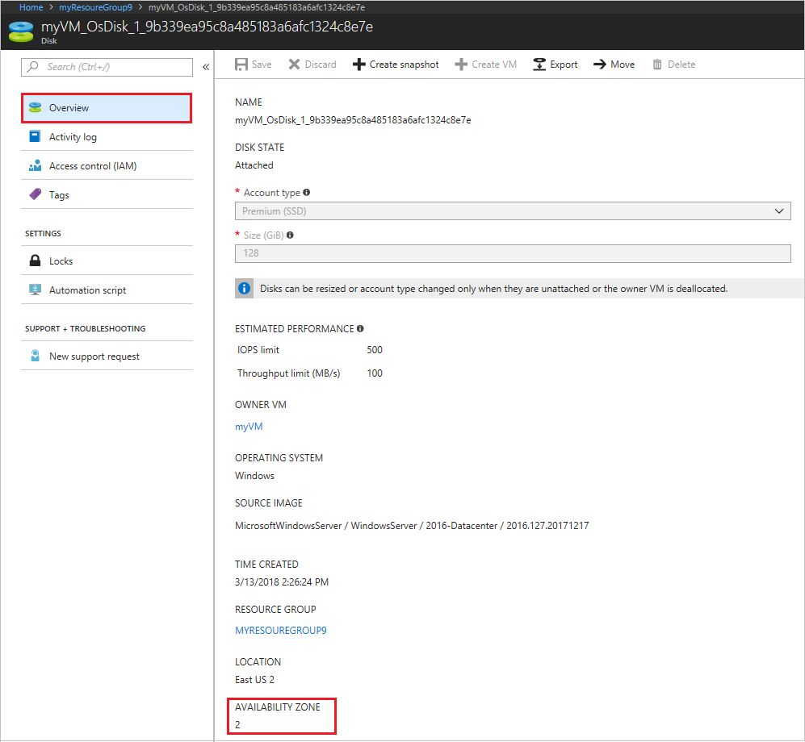
- Click the name of the Public IP address resource. The Overview page includes details about the location and availability zone of the resource.
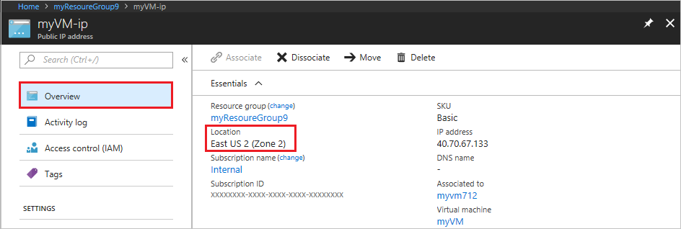

Configuring Networking
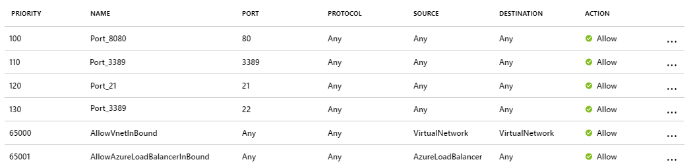

Enabling FTP in Windows
In this example, we will use Windows Server 2008 R2 to configure FTP.
If IIS is not installed,
- Navigate to Start > Control Panel > Administrative Tools > Server Manager in Windows Server Manager
- Go to Roles node. Right-click on Roles, and click Add Roles.
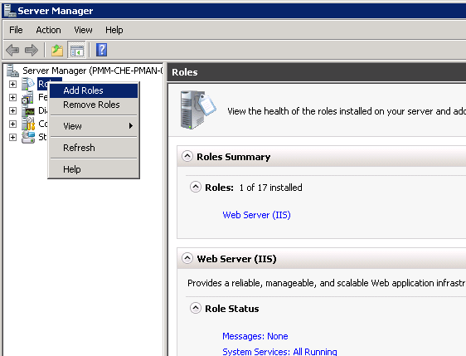

- Right-click on Web Server (IIS), and click on Add Role Services.
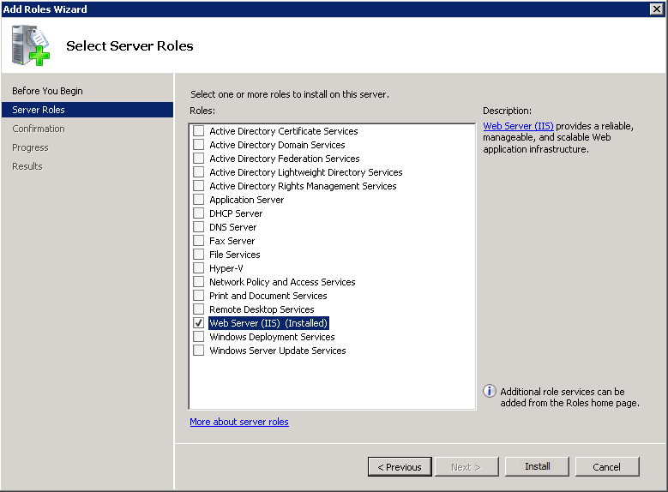
- Confirm that IIS Management Console is checked under Management Tools.
If IIS is installed already (as a Web server),
- Navigate to Start > Control Panel > Administrative Tools > Server Manager
- In the Windows Server Manager, go to Roles node, and expand Web Server (IIS).
- Right-click on Web Server (IIS), and click on Add Role Services.

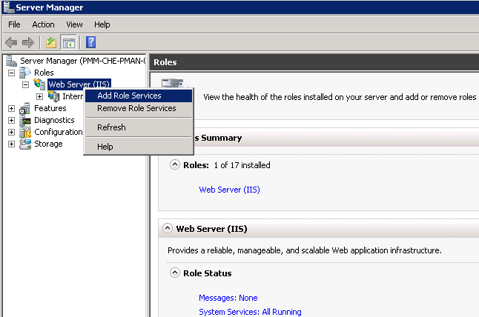

- In the Add Role Services window, go to Roles Services, and check FTP Server.
- Confirm that IIS Management Console is checked under Management Tools.
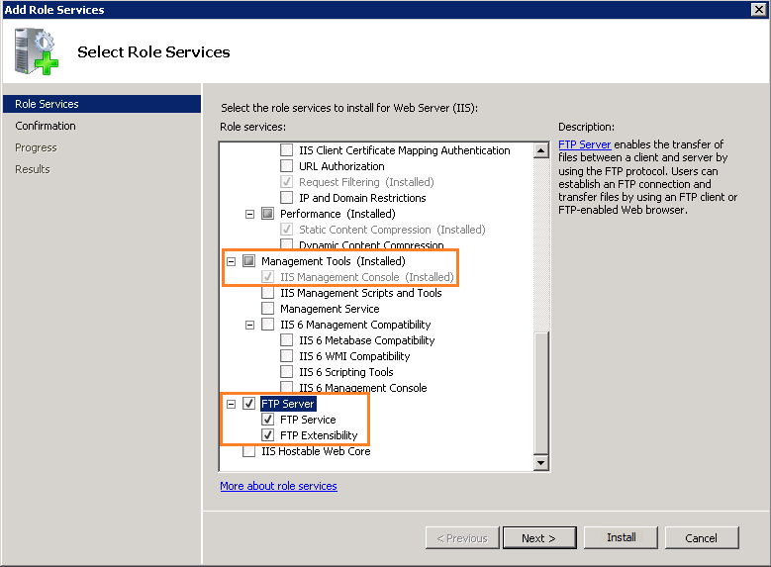

- Click Next, and then Install. Wait for the installation to complete.
Transferring files
To transfer files, you should add an FTP site. Once the FTP site is enabled, clients can transfer to and from the site using the FTP protocol.
Setting up an FTP site
- Navigate to Start > Control Panel > Administrative Tools > Internet Information Services (IIS) Manager.
- Once the IIS console is open, expand the local server.
- Right-click on Sites, and click on Add FTP Site.
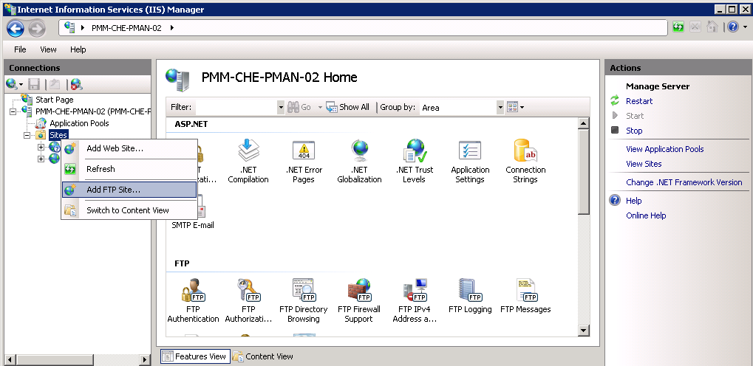
- In the Add FTP Site window, type the FTP server name and the content directory path, and click Next. The directory path should be the same as the one we set permissions to allow anonymous access above, we used:
%SystemDrive%\ ftp \ftproot
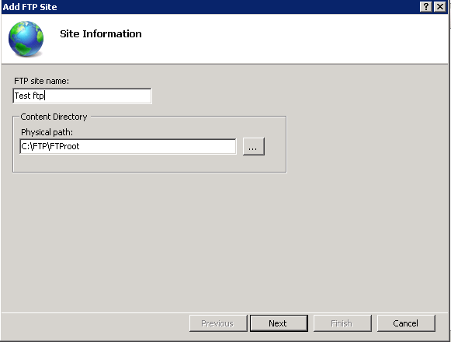
- In the Binding and SSL Settings window, type the IP address of the server. Check the Start FTP Site Automatically option. Choose SSL Based on Constraint. Click Next.
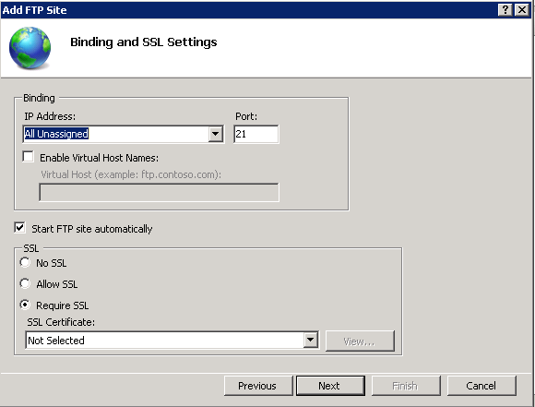
- Now, select Basic for authentication.
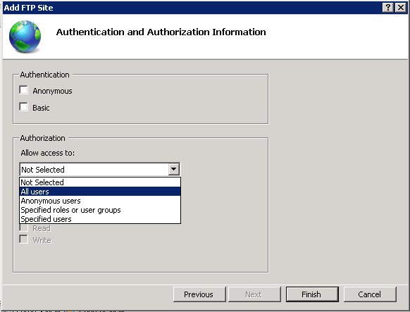
Note: Basic authentication means there is no encryption used. Thus, username/password are sent in clear text. Basic authentication matches the username/password from the Active Directory database. You can also create accounts in IIS. This can be done from under Management Tools in Web Server (IIS) role. Under Authorization, you can select All Users to allow FTP access to all users from the domain. Also, check both Read and Write under Permissions Based on Requirement.
Click Finish. Now, the FTP site creation is complete.
Accessing files on the FTP server
To access files on the FTP server, open a file explorer and type ftp://serverIP. The FTP server asks for a username and password. Enter the username and password (Windows or Active Directory credentials) and click Logon. The files and folders display under the FTP server.
